Cell Line: HEK293A.GFP-LC3
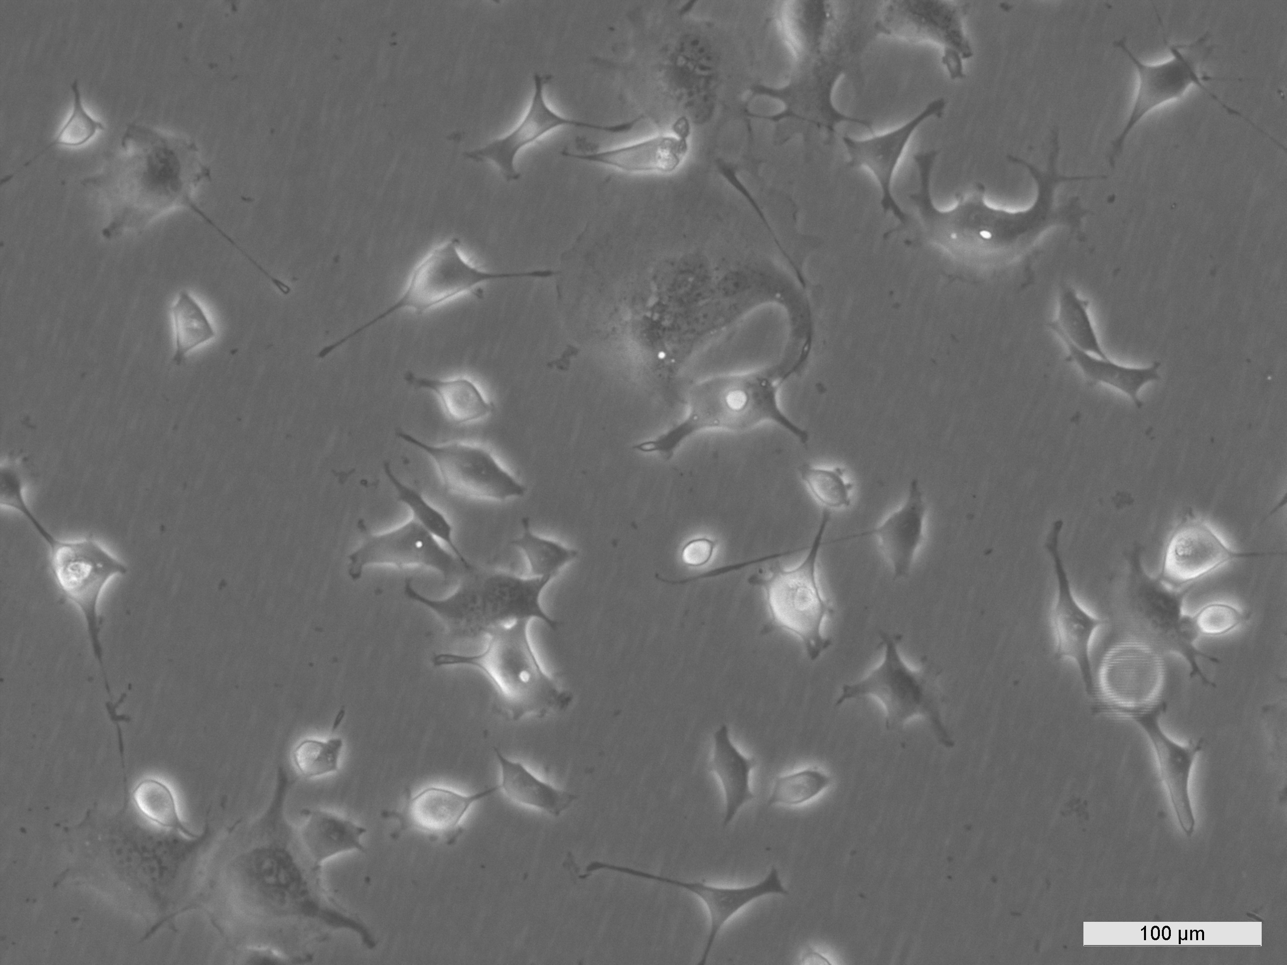
ECACC 14050801 HEK293A.GFP-LC3 Early log-phase
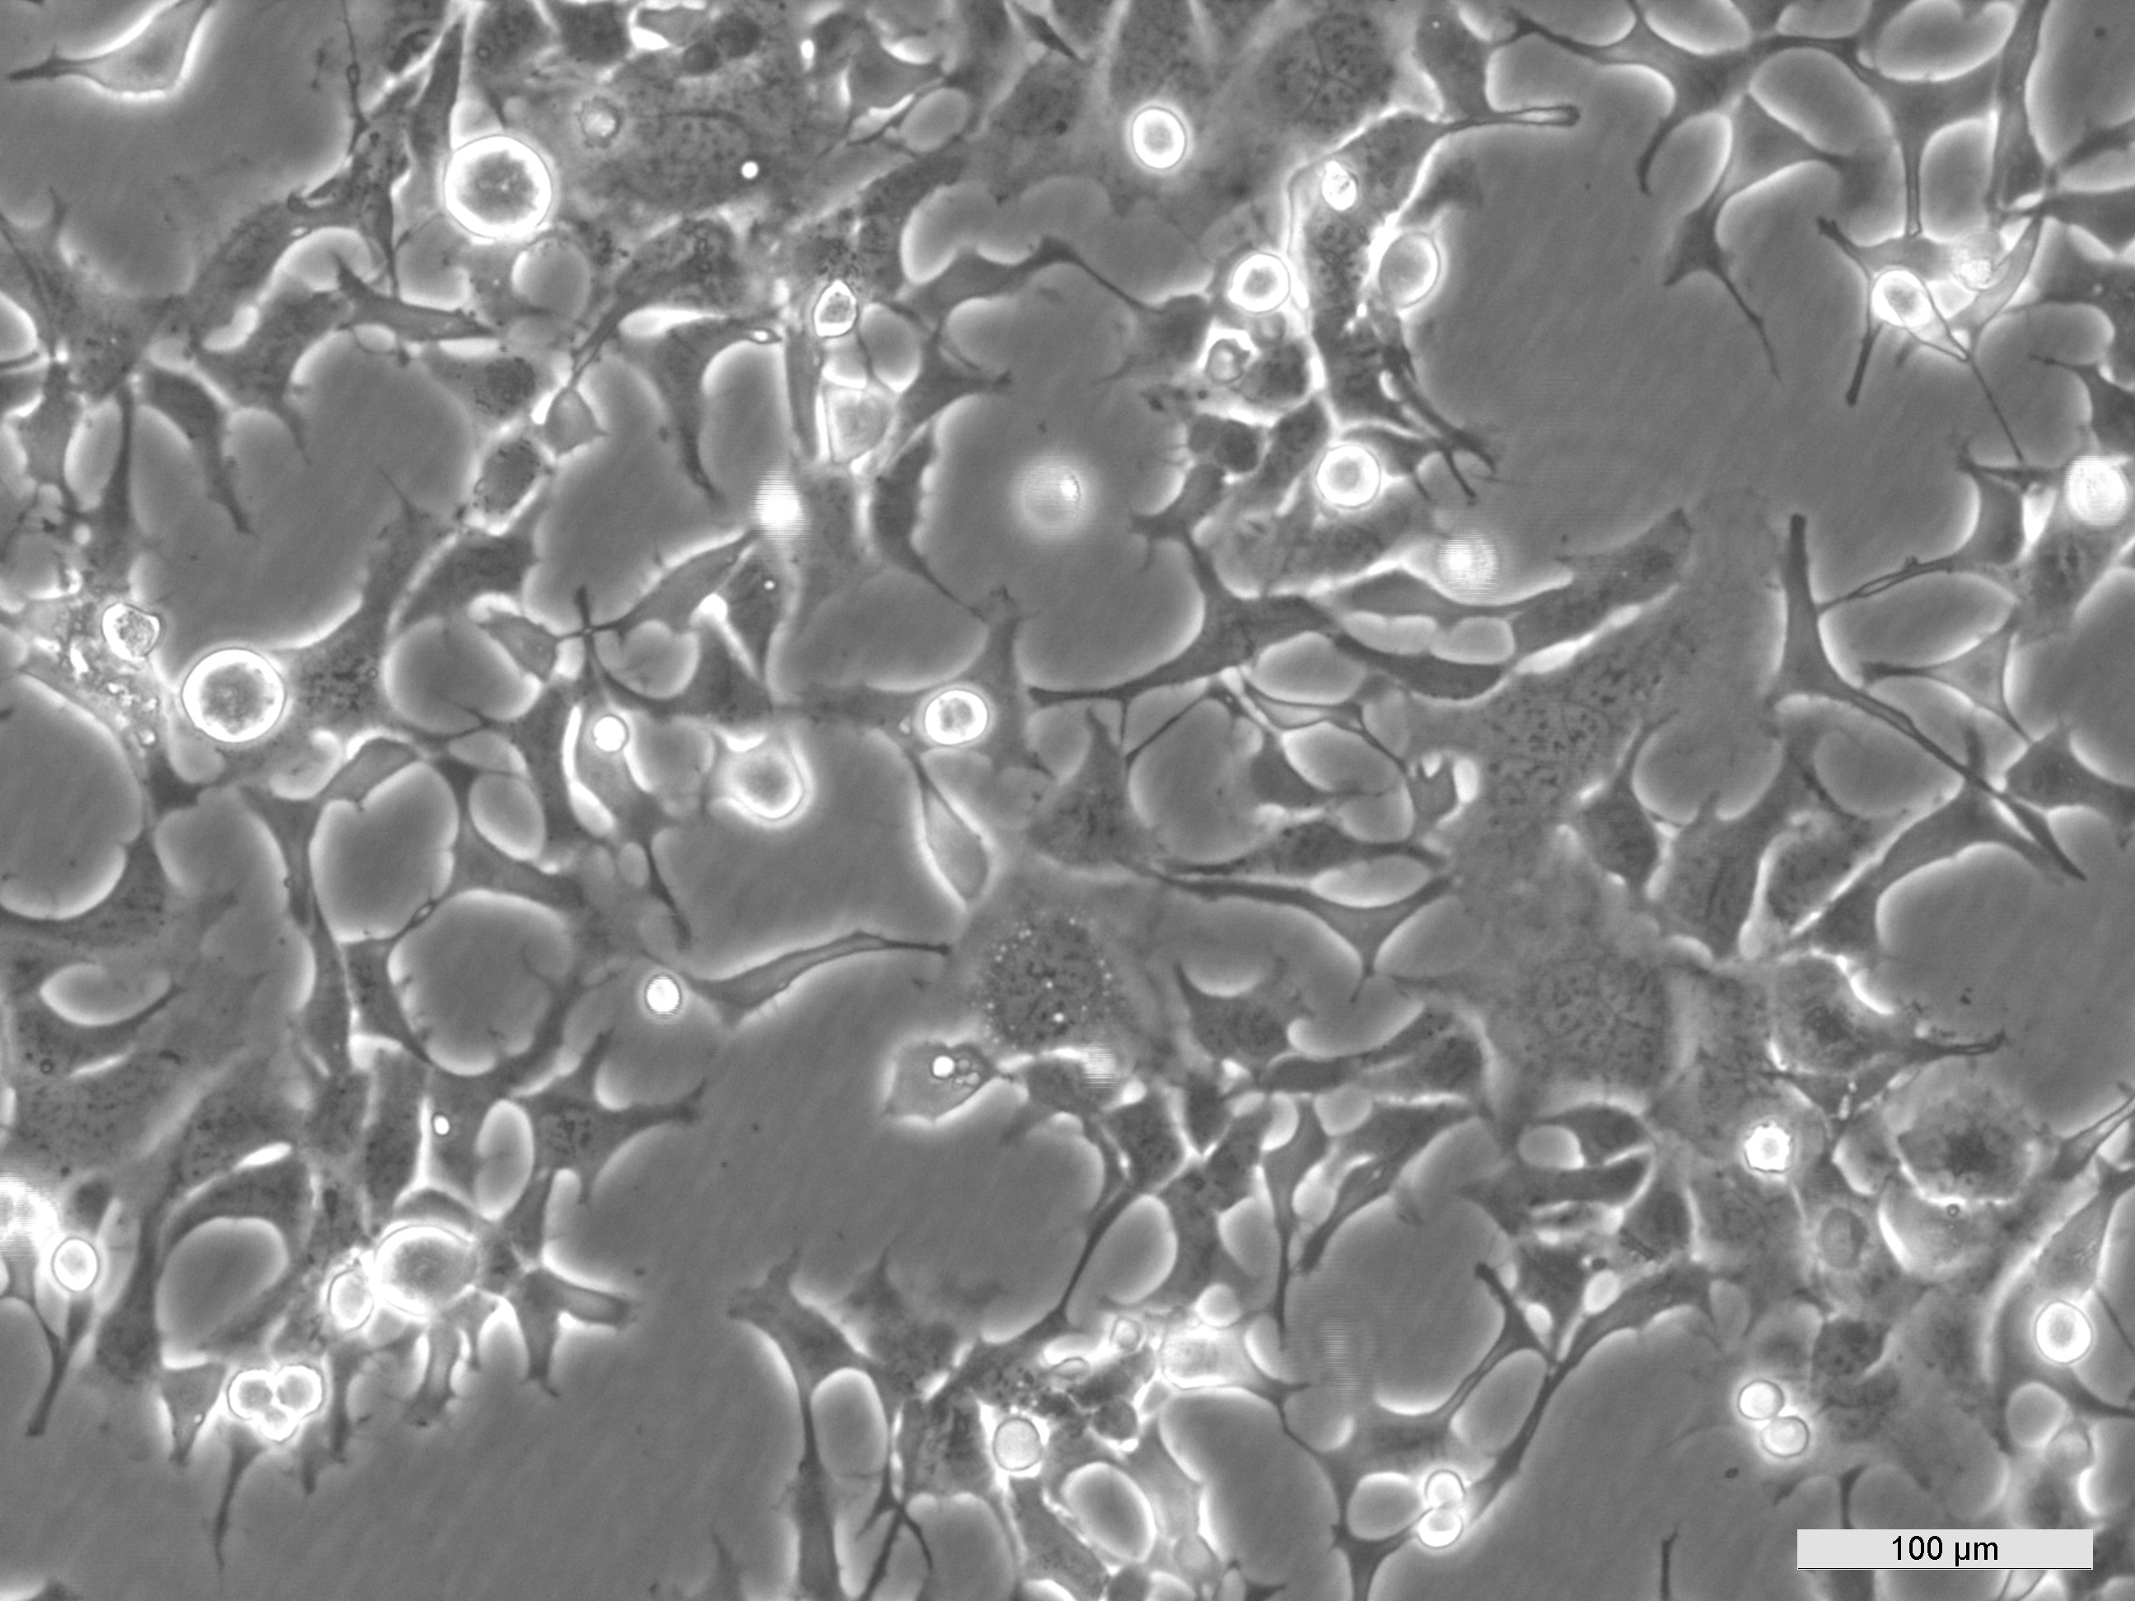
ECACC 14050801 HEK293A.GFP-LC3 Mid log-phase

