Cell Line: H129-2

Catalogue Number: 14040205

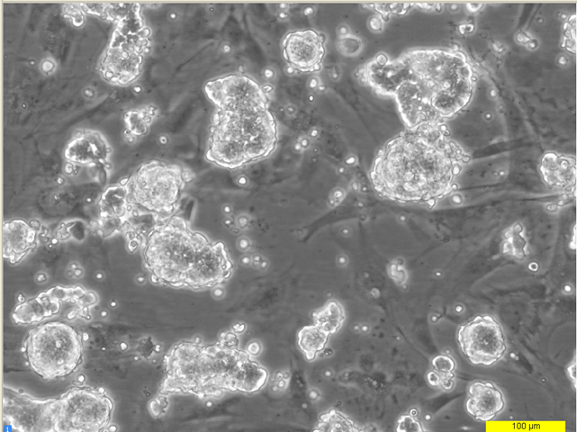

96 hours post resuscitation