Cell Line: ULK1(-/-), ULK2(-/-) DKO (SV40)
Catalogue Number: 14050802
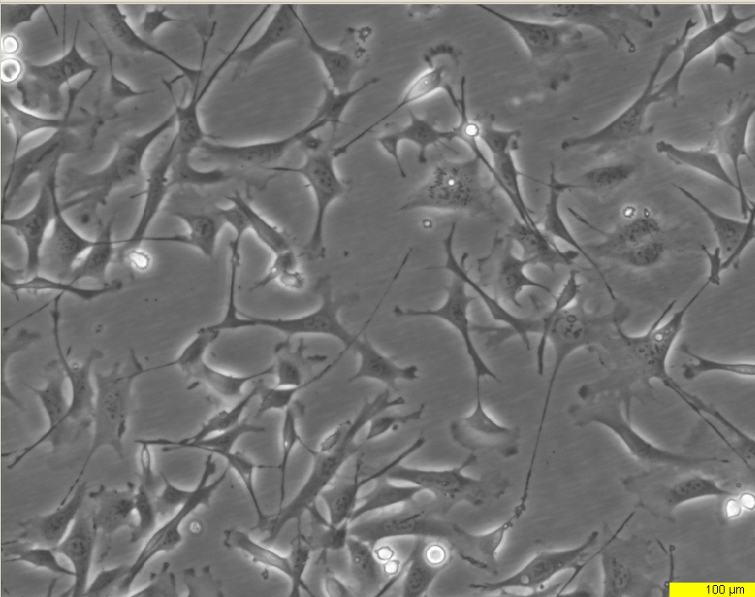
Early log phase 24hrs

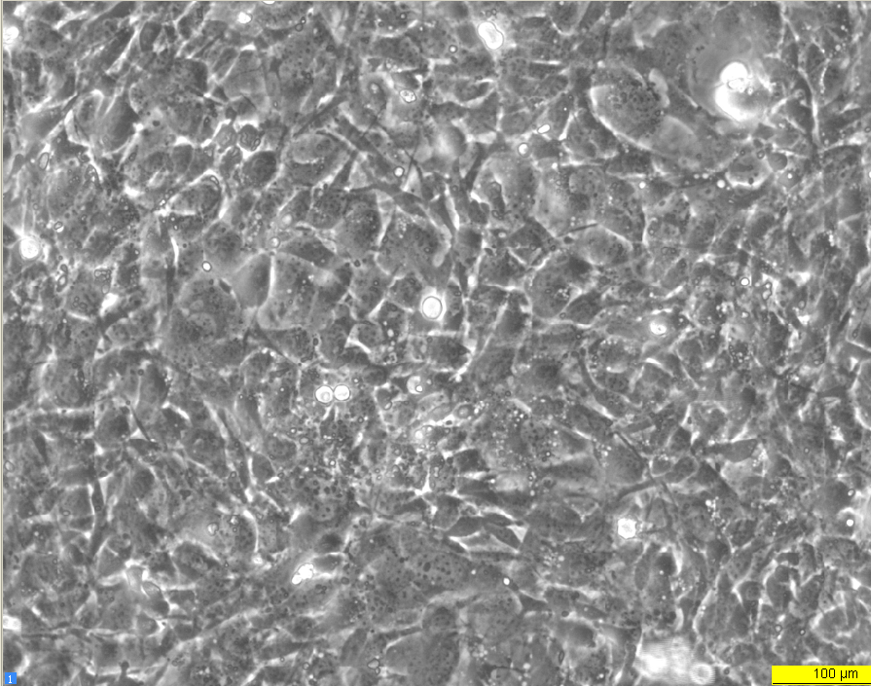
Late log phase 72hrs

