Images for cell line L929/A

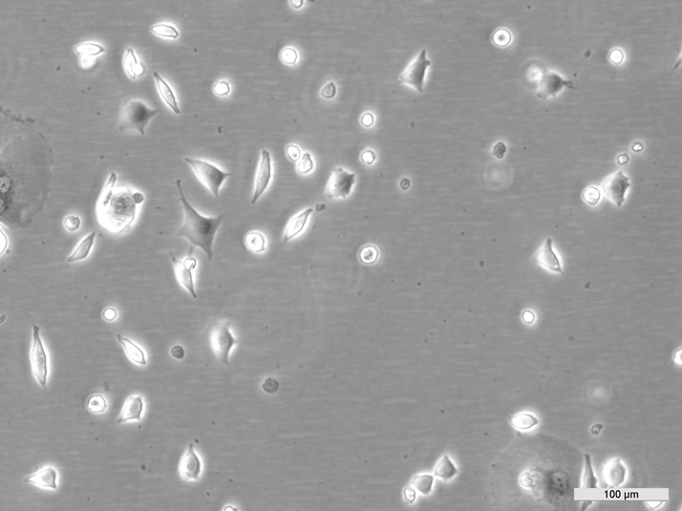
ECACC14112101 L929/A Early log-phase
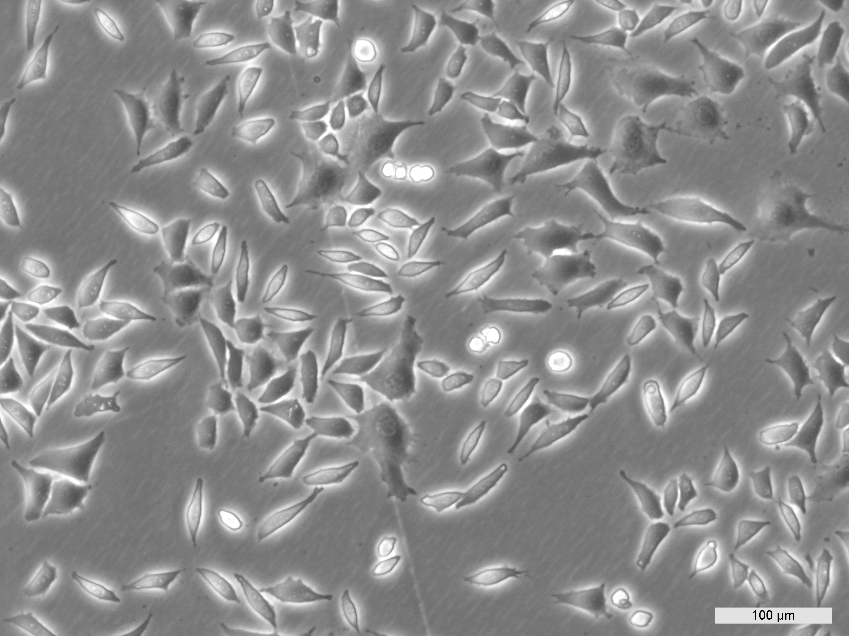
ECACC14112101 L929/A Mid log-phase
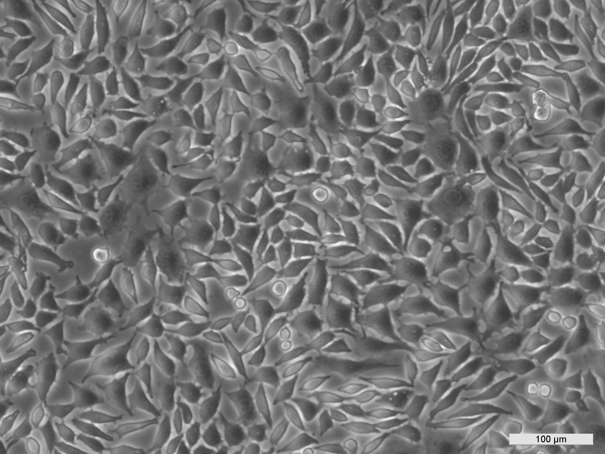
ECACC141121011 L929/A Late log-phase

