Cell Line: ULK1/2 WT (SV40)
Catalogue Number: 14050804
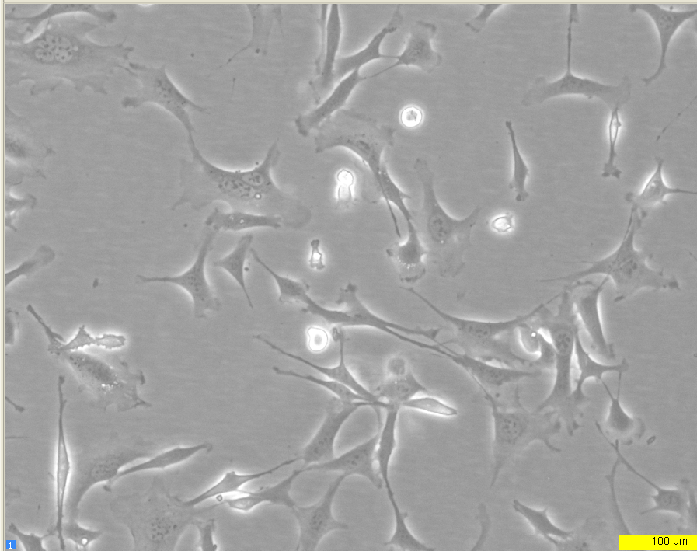
Early log phase 24 hours

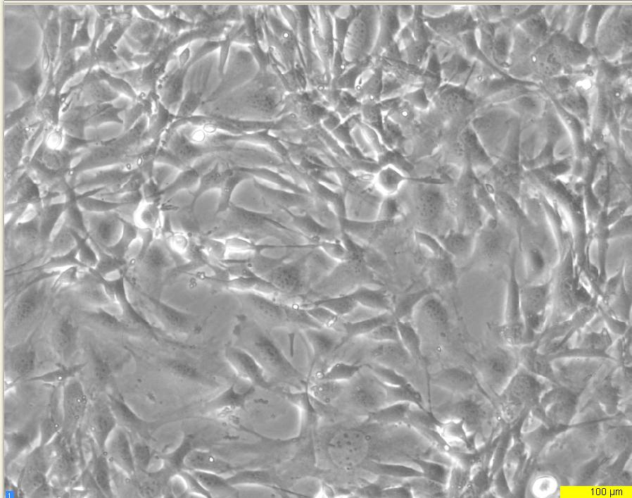
Late log phase 72 hours

